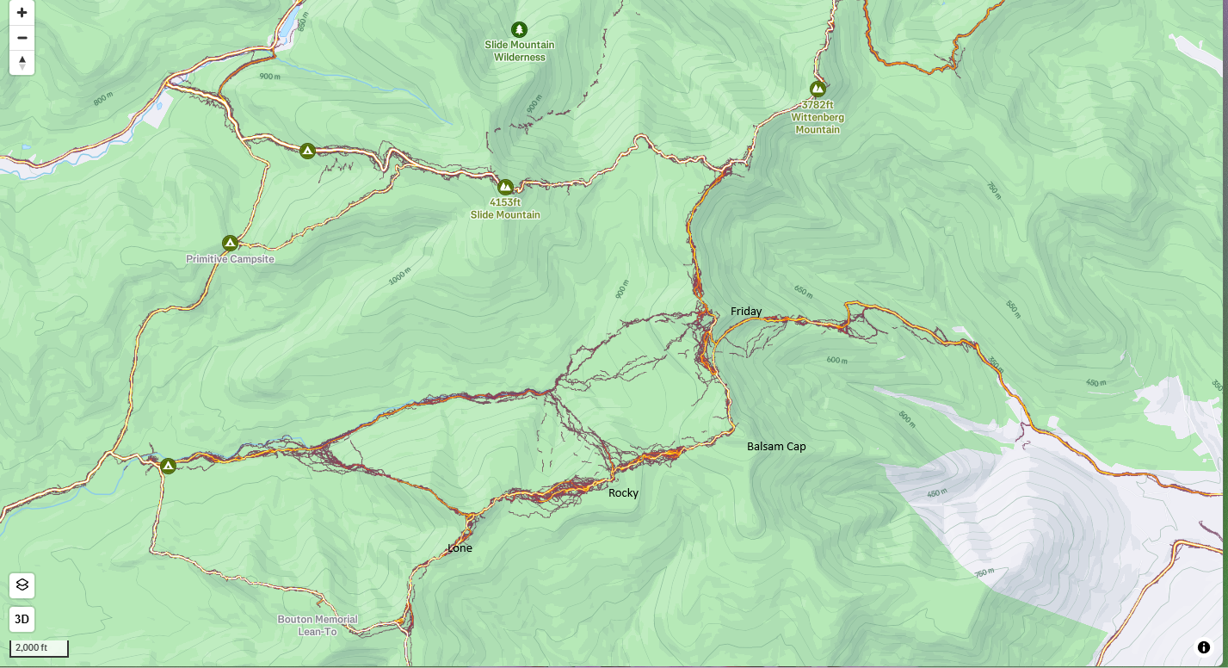
Visitor created, informal trail network to Lone, Rocky, Balsam Cap and Friday as seen on STRAVA.. These are the peaks that have canisters at the summits.

